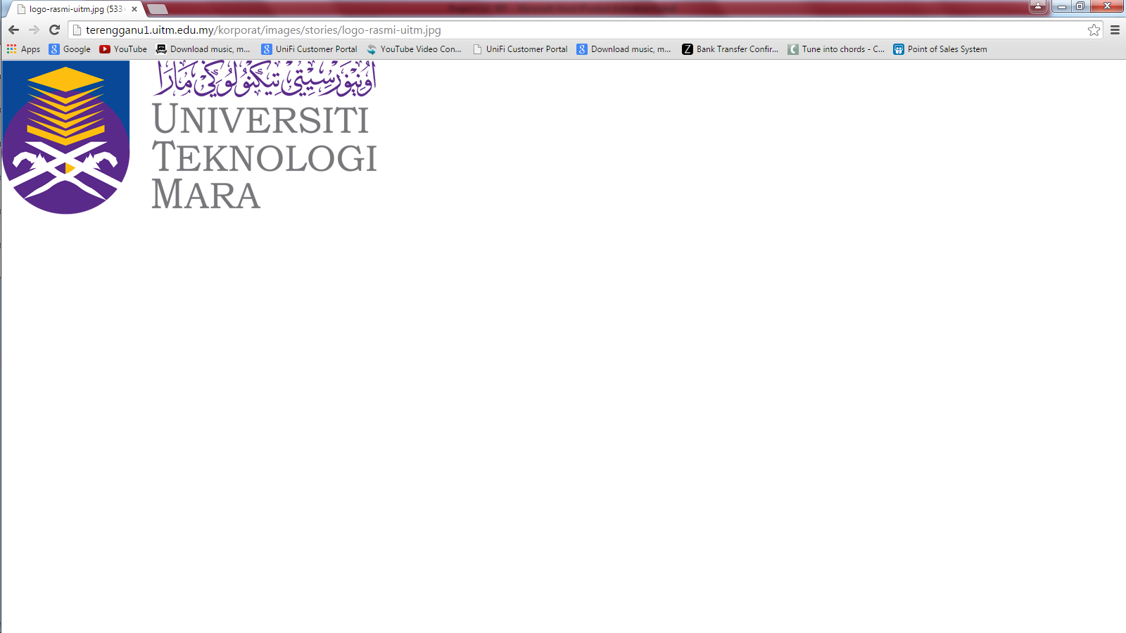

CSC305 Group Project Report

|  |  |
| --- | --- |
| Member | ID |
| MOHD IRFAN BIN JULAIHI | 2011433292 |
| MUHAMMAD ADLI FADLI BIN ROSLI | 2012486806 |
| JASMINE AK FELIXSON | 2012673346 |

Submitted to:

MR LEE BEE YONG

Introduction

We from IT MAGiC decided to do Point of Sales information system project that selling Handphones. The aim of this project is to be able to help the cashier with computerized, systematic, and correlated retail information with regards to the products that they purchase with their respective prices ,the quantity purchased, with less time burden. With this we come up data flow and diagram of the project so it is easier for non programmer to understand this system.The programming language that will be used to create this Point of Sales system is C, Python, and Scheme.

Data flow and diagram

Select Menu

Select =1

Generate change

Enter cash received

Compute price

Enter number of quantities

Choose Product

View Product

Select=2

View total sales, cash received and total balance.

No

Yes

Receipt print

Print receiptptpt

r

Screenshot of program(C programming language)

1.Menu option

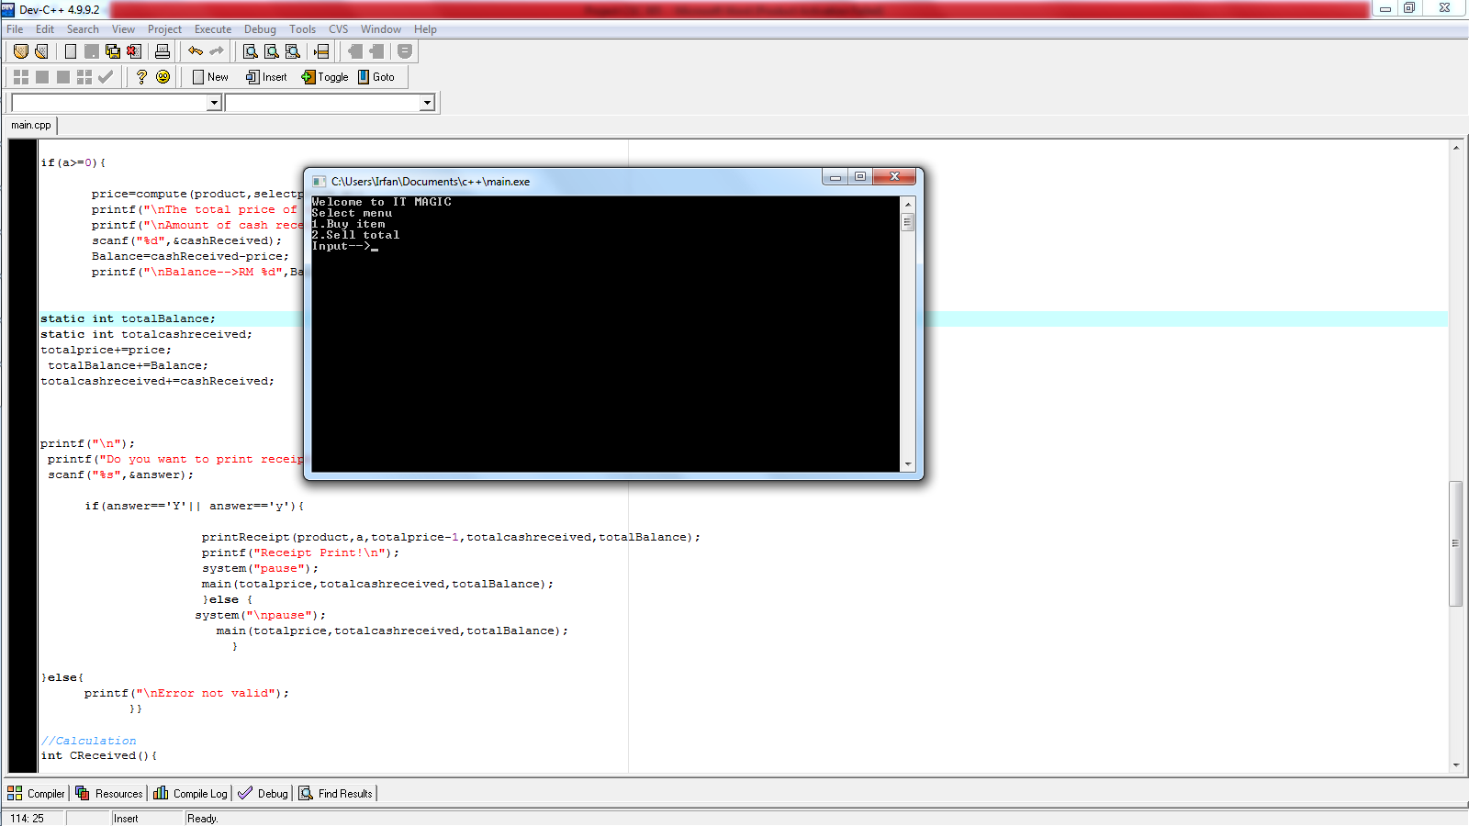

2.The user put input 1

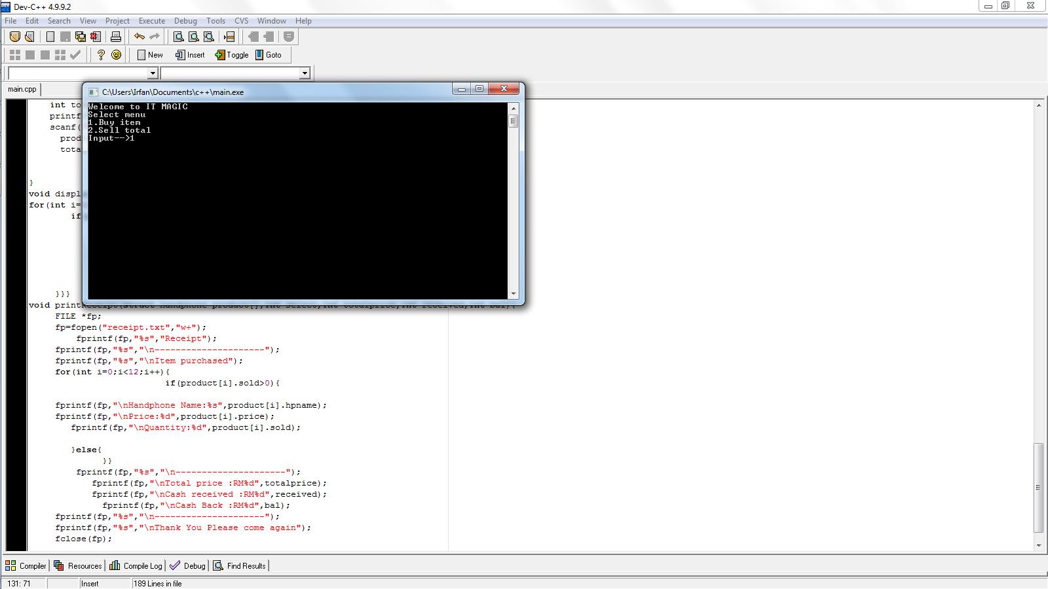

3.Then menu display all item available.

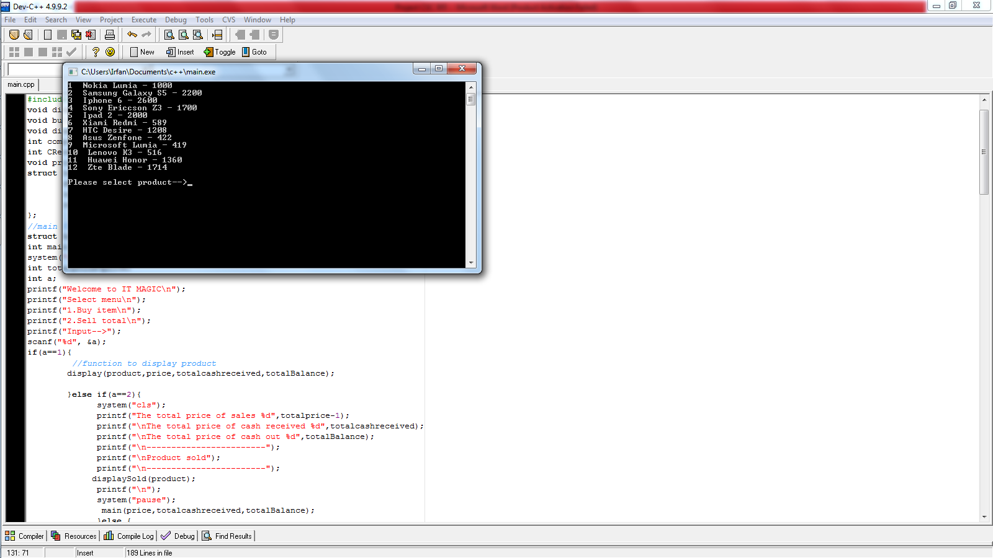

4.The user select product(for example :product 10).

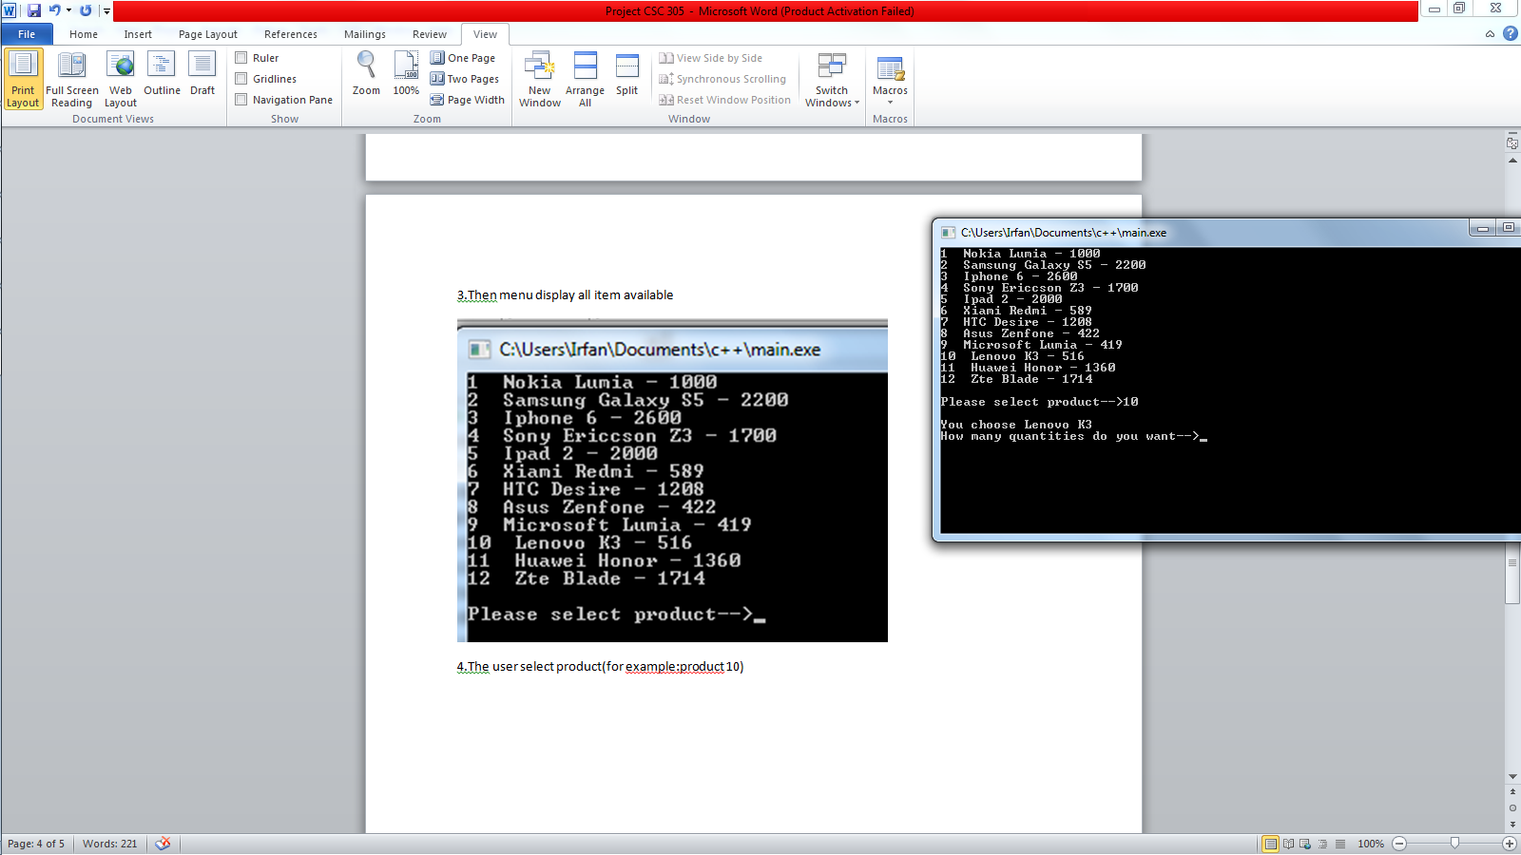

5.The user choose how many quantity they desire(for example :9).

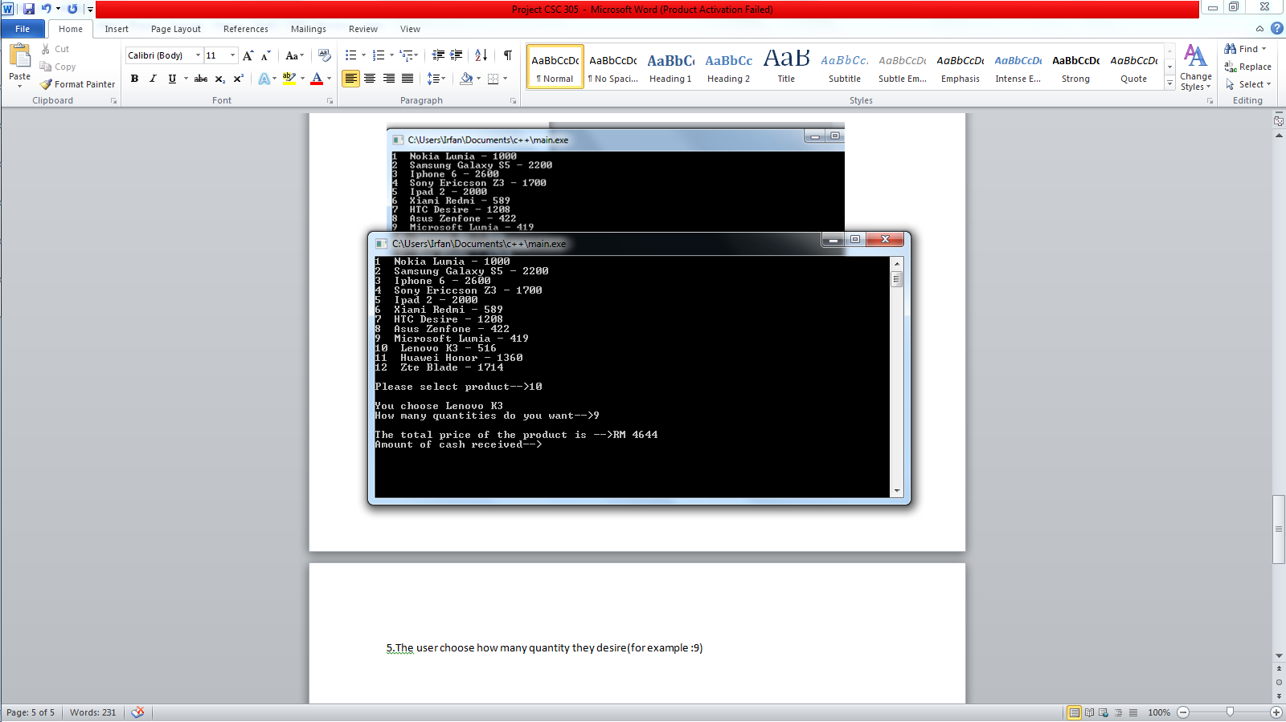

6.The user enter the amount of cash received by the customer and the balance will be generate.

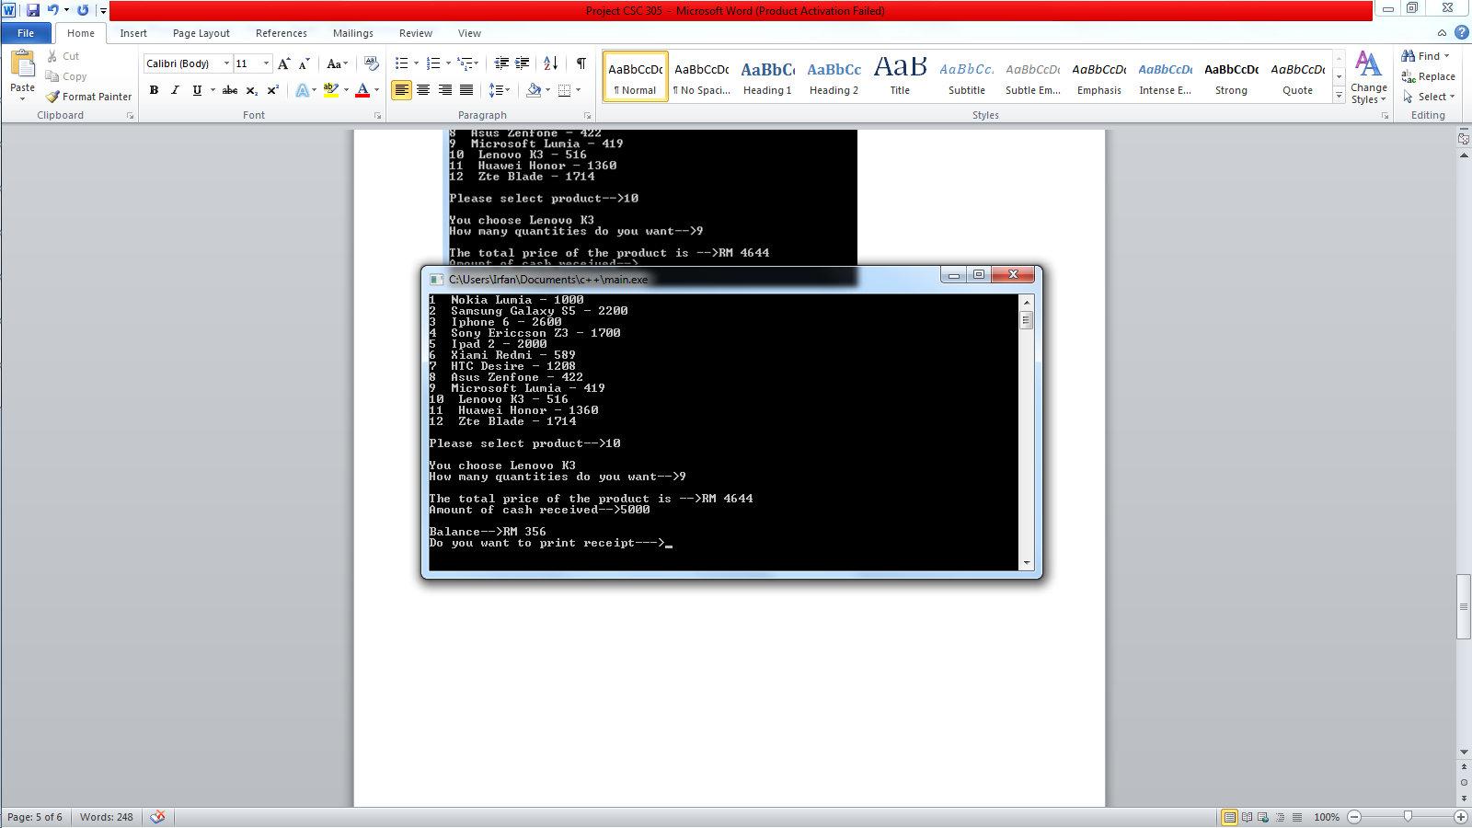

7.The program will ask if the user want to print receipt….enter Y for yes or N for no.If the customer want to purchase another item enter ‘n’ to do more transaction..repeat step 2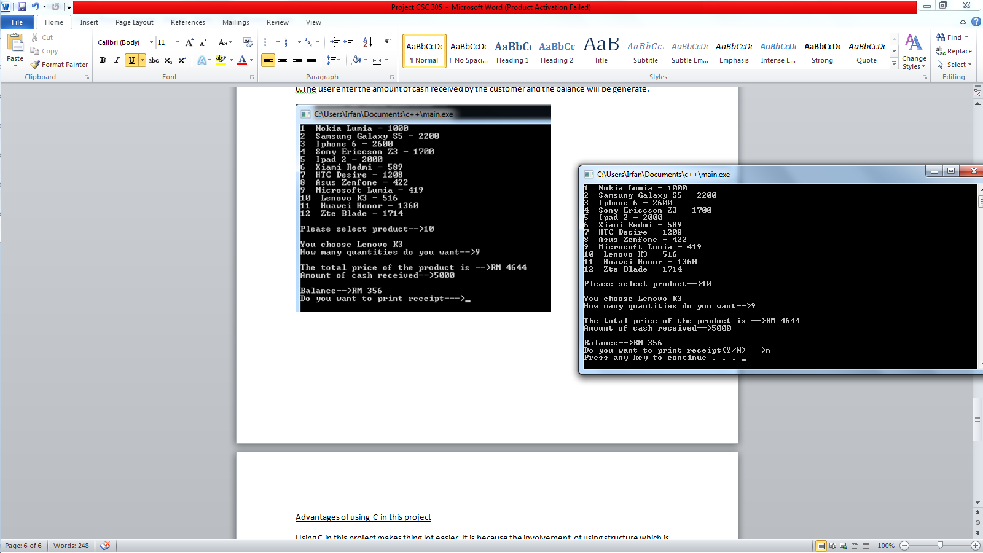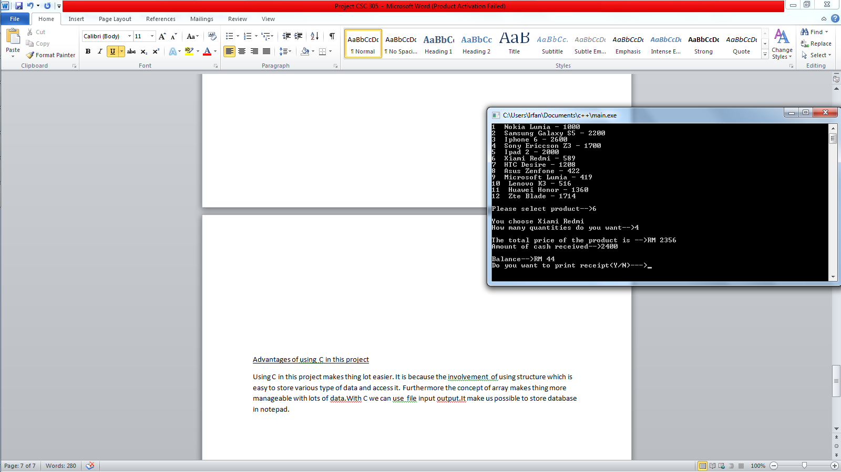

8.If the customer want a receipt the user can issue a receipt.

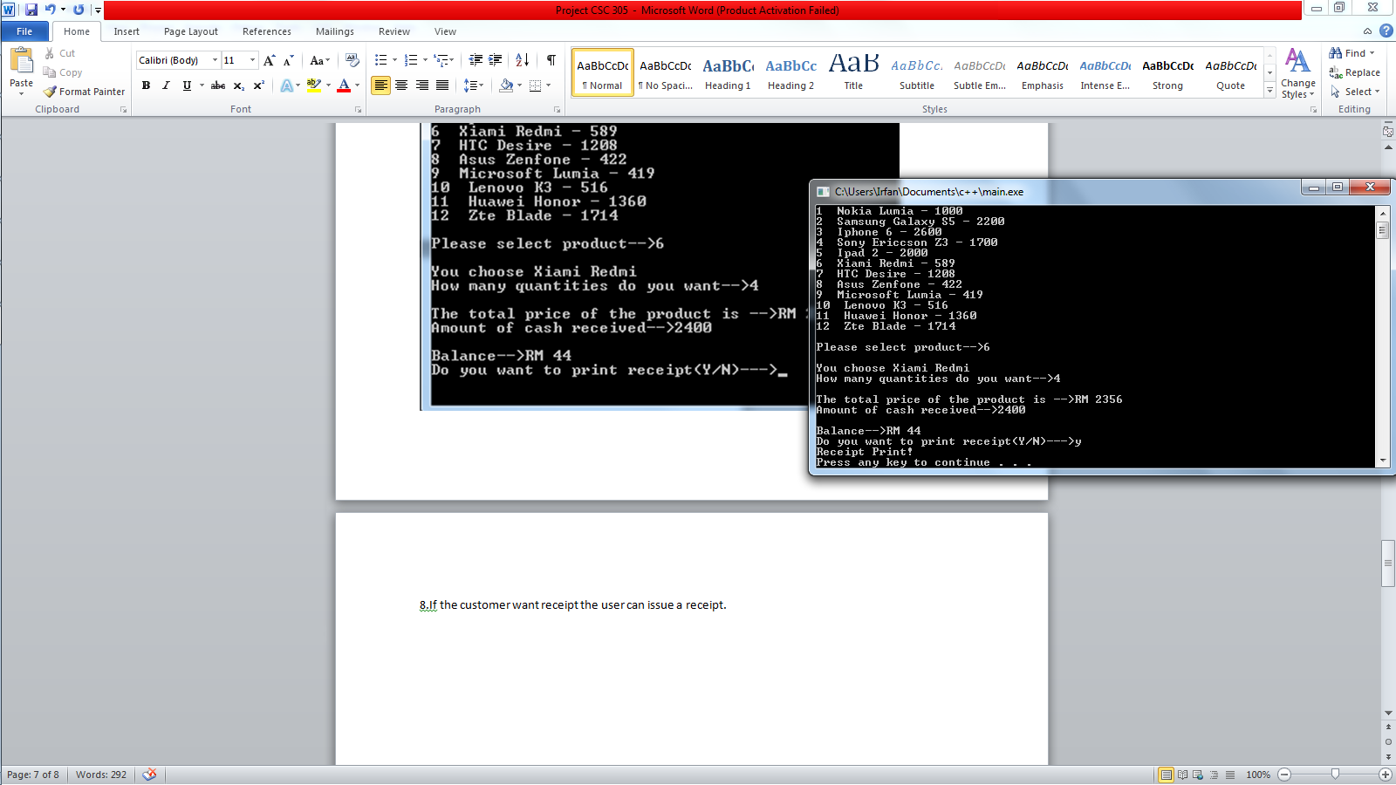

Example of receipt

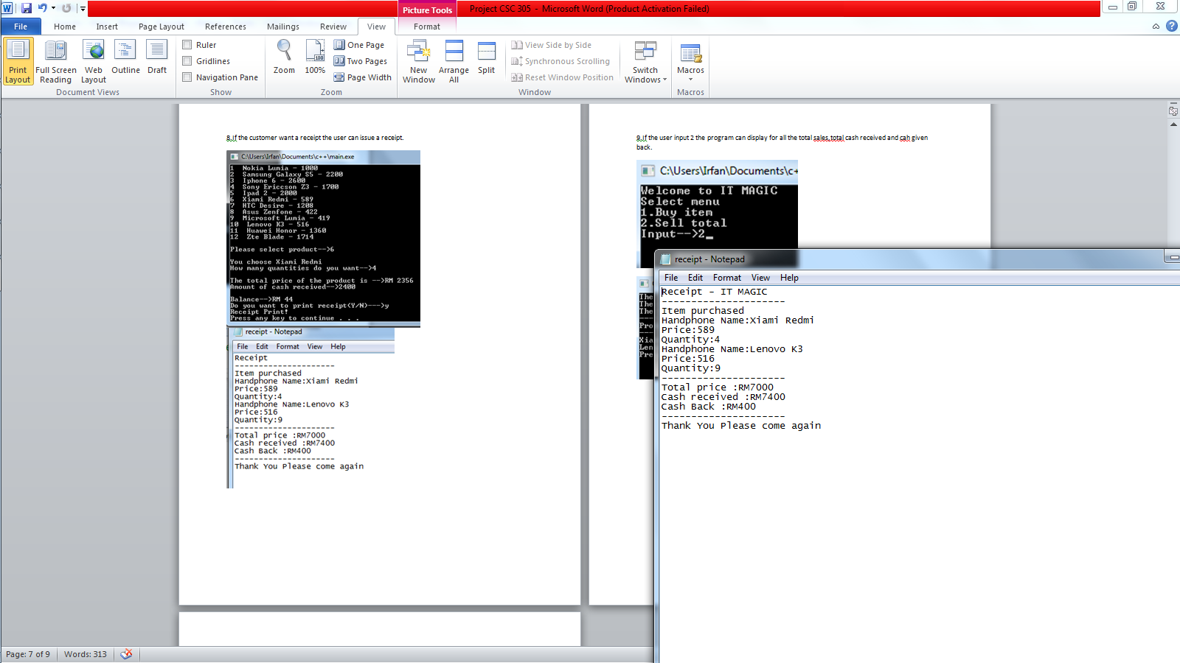

9.If the user input ‘2’ in the program can display for all the total sales,total cash received and cah given back.

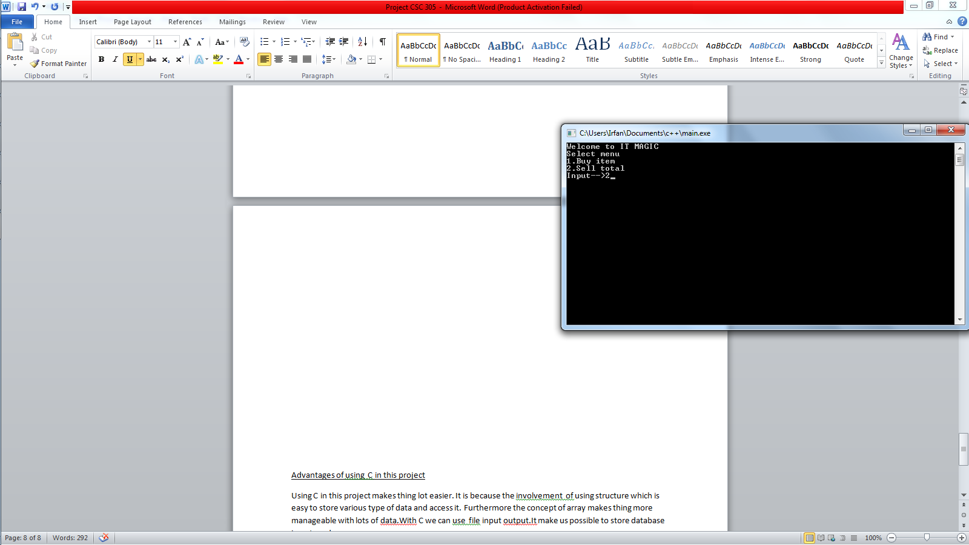

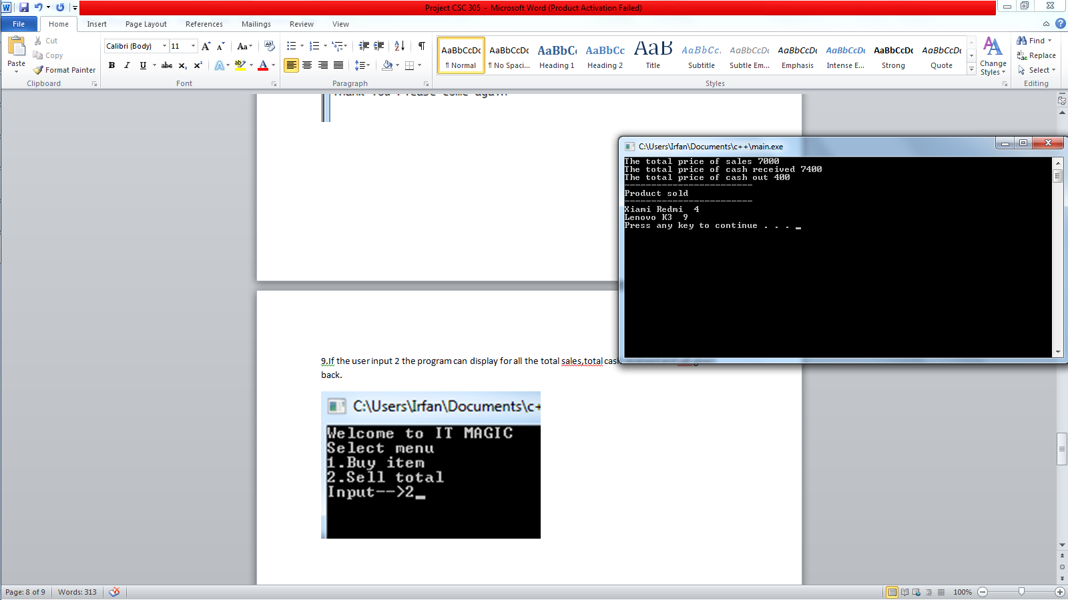

Conclusion of using C programming language in this project

Using C in this project makes thing lot easier. It is because the involvement of using structure which is easy to store various type of data. Besides that the use of structure enable us to easy manipulate the data to some calculation process Furthermore the concept of array makes thing morestorable with lots of data.The best part of C language compare to other languages is the use file input output .It make us possible to create database in notepad. It means we can easily update the database without do some programming. The conclusion is ,compare to the other language C is the most suitable languages to use because the existence of struct,array and file input output which helps makes things easier to build a complete functional Point of sales system.